Blue bottle

A bottle looks blue in blue light and it looks blue in white light.
Why does the bottle look blue in both kinds of light?

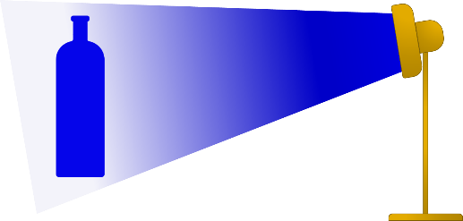
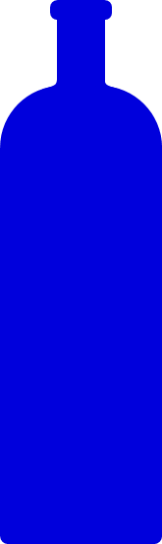

Fill in the gaps to explain why the bottle looks blue.
You should only use the words reflects and absorbs
In blue light
Blue light does not contain any other colour, just blue. When it lights up the bottle, the bottle __________ blue light. We see the light that the bottle __________.
In white light
White light contains all the colours of the spectrum. When the bottle is in white light it __________ blue light. The bottle __________ red light and green light. It __________ all of the colours in white light except for blue.
We see the bottle because of the light that it __________.
Physics > Big idea PSL: Sound, light and waves > Topic PSL2: How we see > Key concept PSL2.2: Seeing in colour
Diagnostic question
Blue bottle

Overview
Learning focus: | Light has colours that are seen when reflected by bodies.
Observable learning outcome: | Describe how coloured objects selectively absorb or reflect particular colours of light.
Question type: | Focused cloze
Key words: | Absorbs, reflects

What does the research say?
To understand why objects look the colour they do students need first to understand the scientific explanation of how we see non-luminous objects that are considered in the key concept: PSL2.1 The ‘passive eye model’ of vision.
In a study of 13-year-olds (n=150), 72% did not think that white light was a mixture of different colours (Zylbersztajn and Watts, 1982; Driver et al., 1994). For a physicist, sunlight and daylight are both examples of white light. Each consists of all the colours of the spectrum which combine to be seen as white. Students often regard white light as ‘pure light’ that is free of any tinge. More than half of a sample of 13- to 16-year-olds (n=166) considered colour to be different to light and something that is added to light (Galili and Hazan, 2000). This idea was covered earlier in this key concept.
This question can identify how students are using key terms, and provides information about their understanding of the selective absorption and reflection of light by coloured objects.
Ways to use this question
Students should complete the activity individually as a pencil and paper exercise. The text on the worksheet is larger than standard so that the sheet can be copied at A5-size.
How students fill in the gaps will show you whether they understood the concept sufficiently well to apply it correctly.
If there is a range of answers, you may choose to respond through structured class discussion. Ask one student to explain why they gave the answer they did; ask another student to explain why they agree with them; ask another to explain why they disagree, and so on. This sort of discussion gives students the opportunity to explore their thinking and for you to really understand their learning needs.
Differentiation
You may choose to read the sentences to the class, so that everyone can focus on the science. In some situations it may be more appropriate for a teaching assistant to read for one or two students.

Equipment
For the class:
- Torch (or other bright light)
- Blue filter
- Blue object (as close to the colour of the filter as possible)
A blue object can be shown to appear blue in both blue light and in white light.
Expected answers
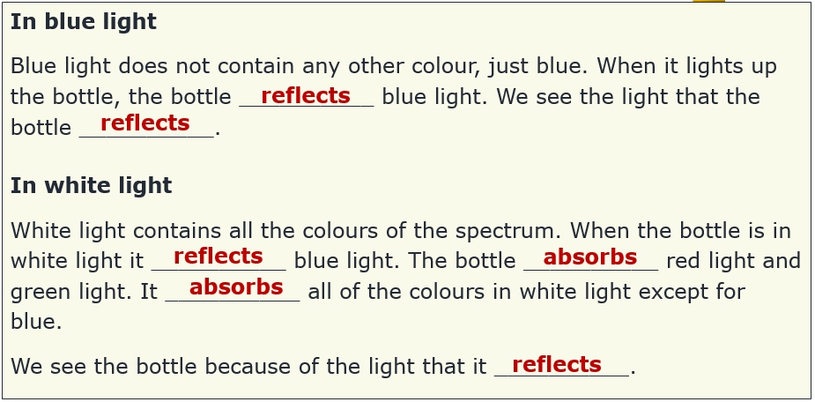
On the PowerPoint a mouse click reveals the answers one by one.
How to respond - what next?
The word reflect is quite straightforward for students to understand as light bouncing off a surface. The word absorb is more complex because substitute words can have subtly different meanings.
In the dictionary absorb is defined as ‘to take in or soak up’. When thinking about the term absorb students may imagine cloths or sponges soaking up water. Capillary action and surface tension effects can actively draw water into a sponge. By contrast, absorbing light is passive and involves no attraction at all. Coloured objects do not draw in light, they just do not reflect the light that happens to fall on them.
If students have misunderstandings about how coloured objects selectively absorb and reflect light, it can help to give the students an activity in which they can practise using these ideas to consolidate their understanding. This could be writing a description or drawing a labelled picture to illustrate how coloured objects interact with the light falling on them. This response often works best when it involves paired or small group discussions, which encourage social construction of new ideas through dialogue.
The following BEST ‘response activity’ could also be used in follow-up to this diagnostic question:
- Response activity: White king
Acknowledgments
Developed by Peter Fairhurst (UYSEG).
Images: Peter Fairhurst (UYSEG).
References
Driver, R., et al. (1994). Making Sense of Secondary Science: Research into Children's Ideas, London, UK: Routledge.
Galili, I. and Hazan, A. (2000). Learners' knowledge in optics: interpretation, structure and analysis. International Journal of Science Education, 22(1), 57-88.
Guesne, E. (1985). Light. In Driver, R., Guesne, E. & Tiberghien, A. (eds.) Children's Ideas in Science. Milton Keynes: Open University Press.
Zylbersztajn, A. and Watts, D. M. (1982). Throwing some light onto colour. Guildford: Mimeograph, University of Surrey.

